**Object modeling: Object relationships and Communication**

**Assisted Problems**

**Problem 1: Library and Books (Aggregation)**

* **Description**: Create a Library class that contains multiple Book objects. Model the relationship such that a library can have many books, but a book can exist independently (outside of a specific library).
* **Tasks**:
  + Define a Library class with an ArrayList of Book objects.
  + Define a Book class with attributes such as title and author.
  + Demonstrate the aggregation relationship by creating books and adding them to different libraries.
* **Goal**: Understand aggregation by modeling a real-world relationship where the Library aggregates Book objects.

**Sol:**

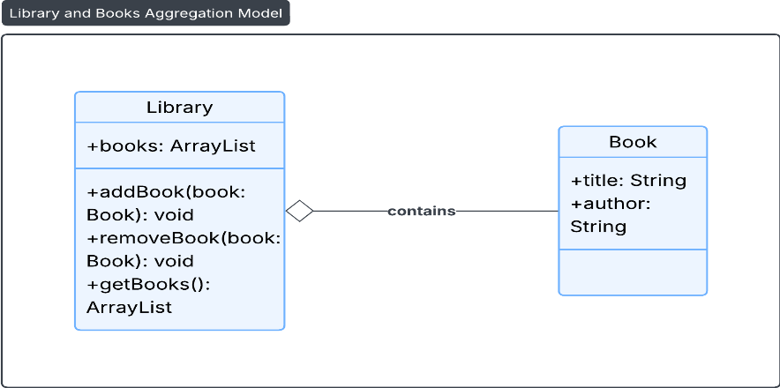

**Problem 2: Bank and Account Holders (Association)**

* **Description**: Model a relationship where a Bank has Customer objects associated with it. A Customer can have multiple bank accounts, and each account is linked to a Bank.
* **Tasks**:
  + Define a Bank class and a Customer class.
  + Use an association relationship to show that each customer has an account in a bank.
  + Implement methods that enable communication, such as openAccount() in the Bank class and viewBalance() in the Customer class.
* **Goal**: Illustrate association by setting up a relationship between customers and the bank.

**Sol:**

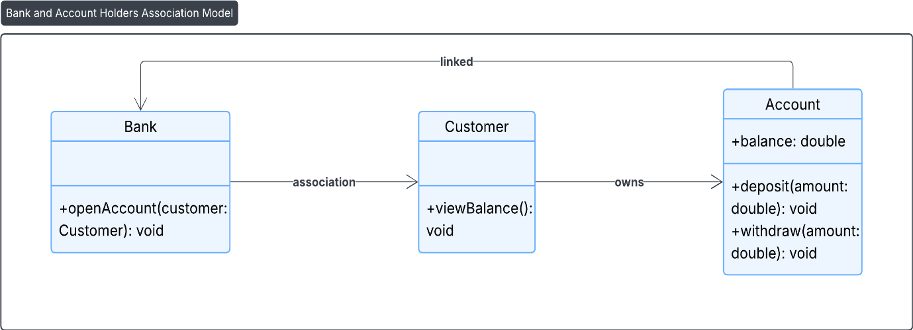

**Problem 3: Company and Departments (Composition)**

* **Description**: A Company has several Department objects, and each department contains Employee objects. Model this using composition, where deleting a company should also delete all departments and employees.
* **Tasks**:
  + Define a Company class that contains multiple Department objects.
  + Define an Employee class within each Department.
  + Show the composition relationship by ensuring that when a Company object is deleted, all associated Department and Employee objects are also removed.
* **Goal**: Understand composition by implementing a relationship where Department and Employee objects cannot exist without a Company.

**Sol:**

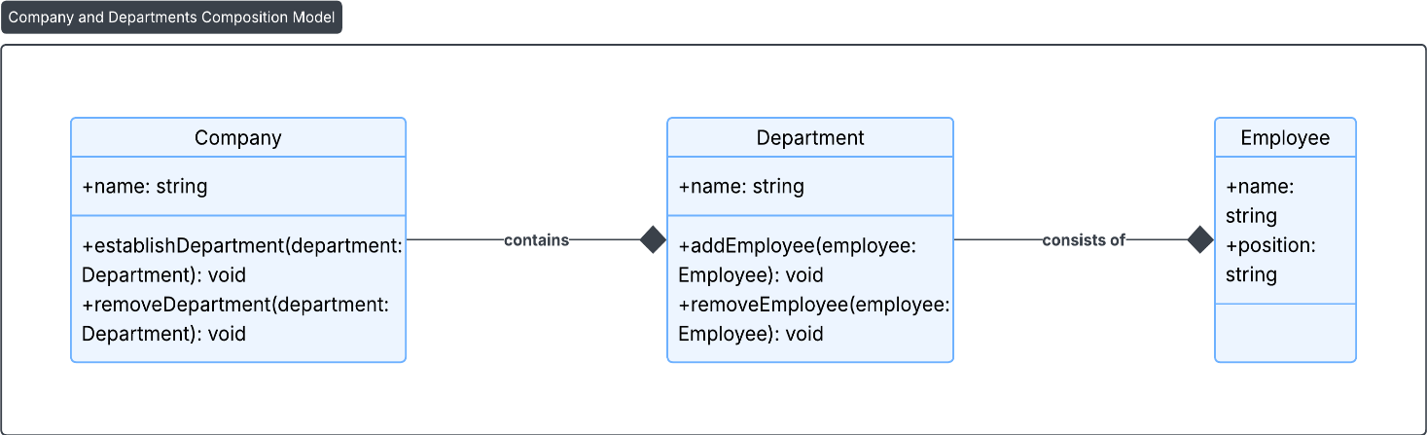

**Self Problems**

**Problem 1: School and Students with Courses (Association and Aggregation)**

* **Description**: Model a School with multiple Student objects, where each student can enroll in multiple courses, and each course can have multiple students.
* **Tasks**:
  + Define School, Student, and Course classes.
  + Model an association between Student and Course to show that students can enroll in multiple courses.
  + Model an aggregation relationship between School and Student.
  + Demonstrate how a student can view the courses they are enrolled in and how a course can show its enrolled students.
* **Goal**: Practice association by modeling many-to-many relationships between students and courses.

**Sol:**

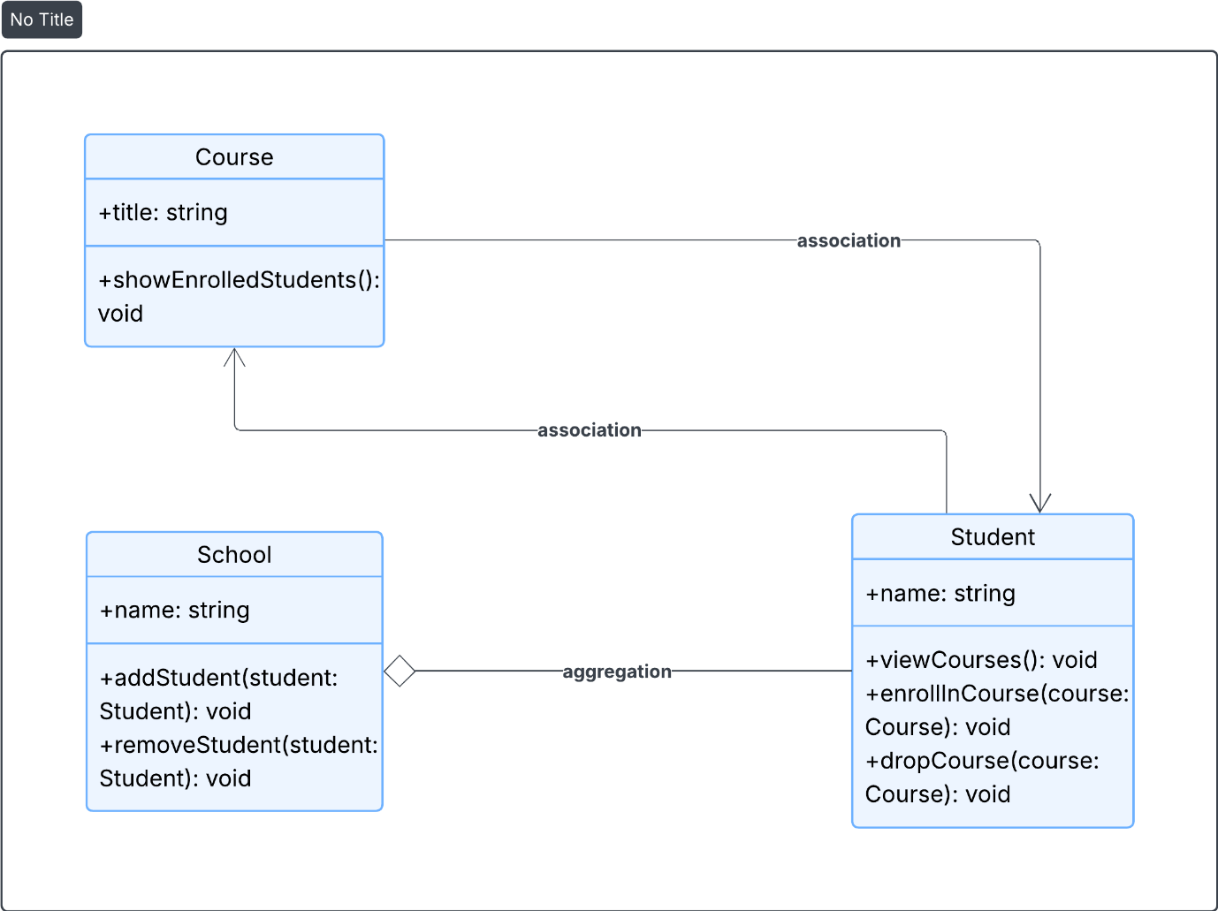

**Problem 2: University with Faculties and Departments (Composition and Aggregation)**

* **Description**: Create a University with multiple Faculty members and Department objects. Model it so that the University and its Departments are in a composition relationship (deleting a university deletes all departments), and the Faculty members are in an aggregation relationship (faculty can exist outside of any specific department).
* **Tasks**:
  + Define a University class with Department and Faculty classes.
  + Demonstrate how deleting a University also deletes its Departments.
  + Show that Faculty members can exist independently of a Department.
* **Goal**: Understand the differences between composition and aggregation in modeling complex hierarchical relationships.

**Sol:**

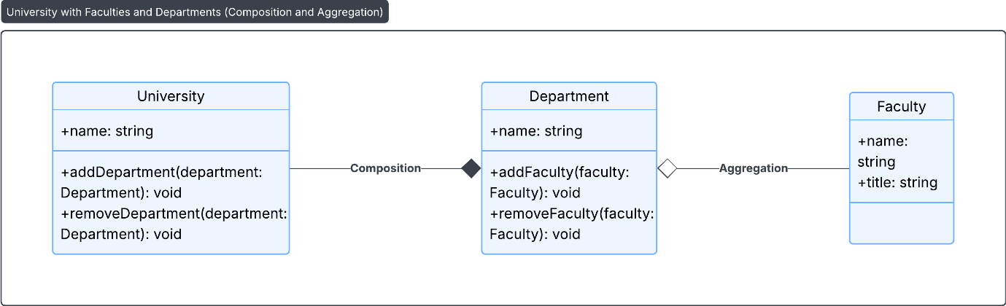

**Problem 3: Hospital, Doctors, and Patients (Association and Communication)**

* **Description: Model a Hospital where Doctor and Patient objects interact through consultations. A doctor can see multiple patients, and each patient can consult multiple doctors.**
* **Tasks:**
  + **Define a Hospital class containing Doctor and Patient classes.**
  + **Create a method consult() in the Doctor class to show communication, which would display the consultation between a doctor and a patient.**
  + **Model an association between doctors and patients to show that doctors and patients can have multiple relationships.**
* **Goal: Practice creating an association with communication between objects by modeling doctor-patient consultations.**

**Sol:**

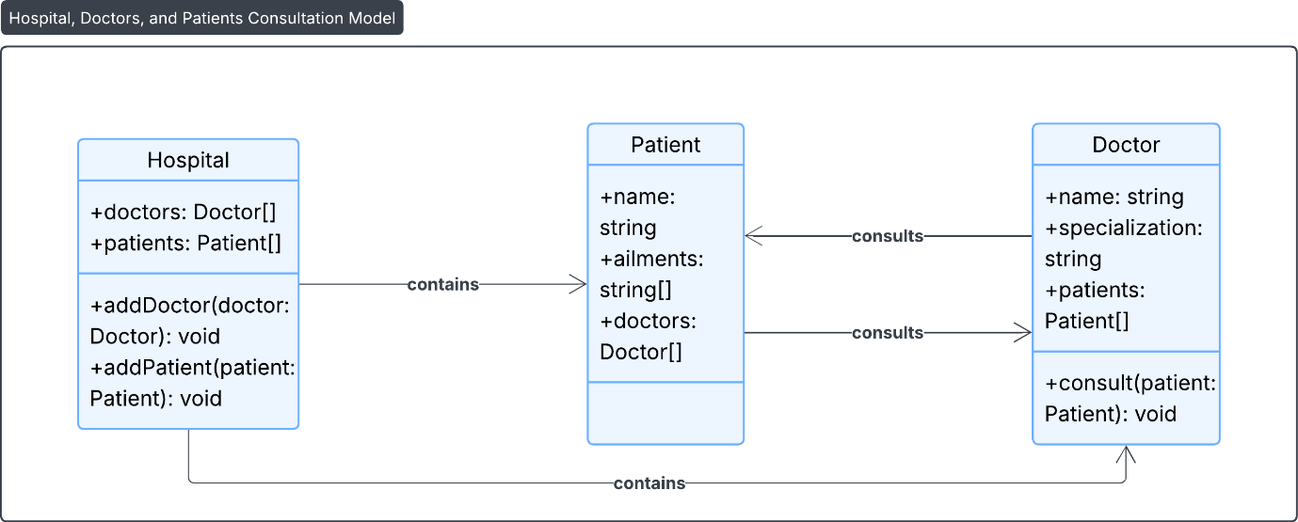

**Problem 4: E-commerce Platform with Orders, Customers, and Products**

* **Description: Design an e-commerce platform with Order, Customer, and Product classes. Model relationships where a Customer places an Order, and each Order contains multiple Product objects.**
* **Goal: Show communication and object relationships by designing a system where customers communicate through orders, and orders aggregate products.**

**Sol:**

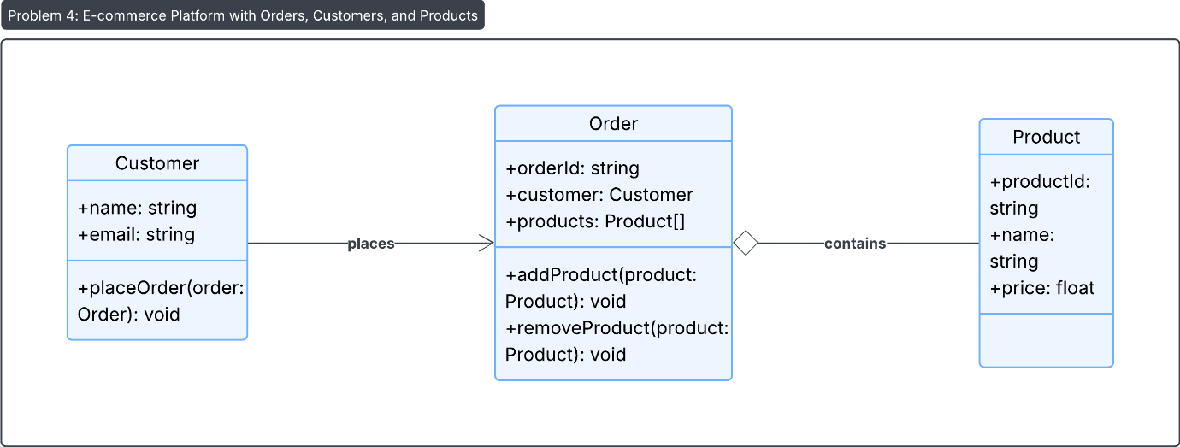

**Problem 5: University Management System**

* **Description: Model a university system with Student, Professor, and Course classes. Students enroll in courses, and professors teach courses. Ensure students and professors can communicate through methods like enrollCourse() and assignProfessor().**
* **Goal: Use association and aggregation to create a university system that emphasizes relationships and interactions among students, professors, and courses.**

**Sol:**

